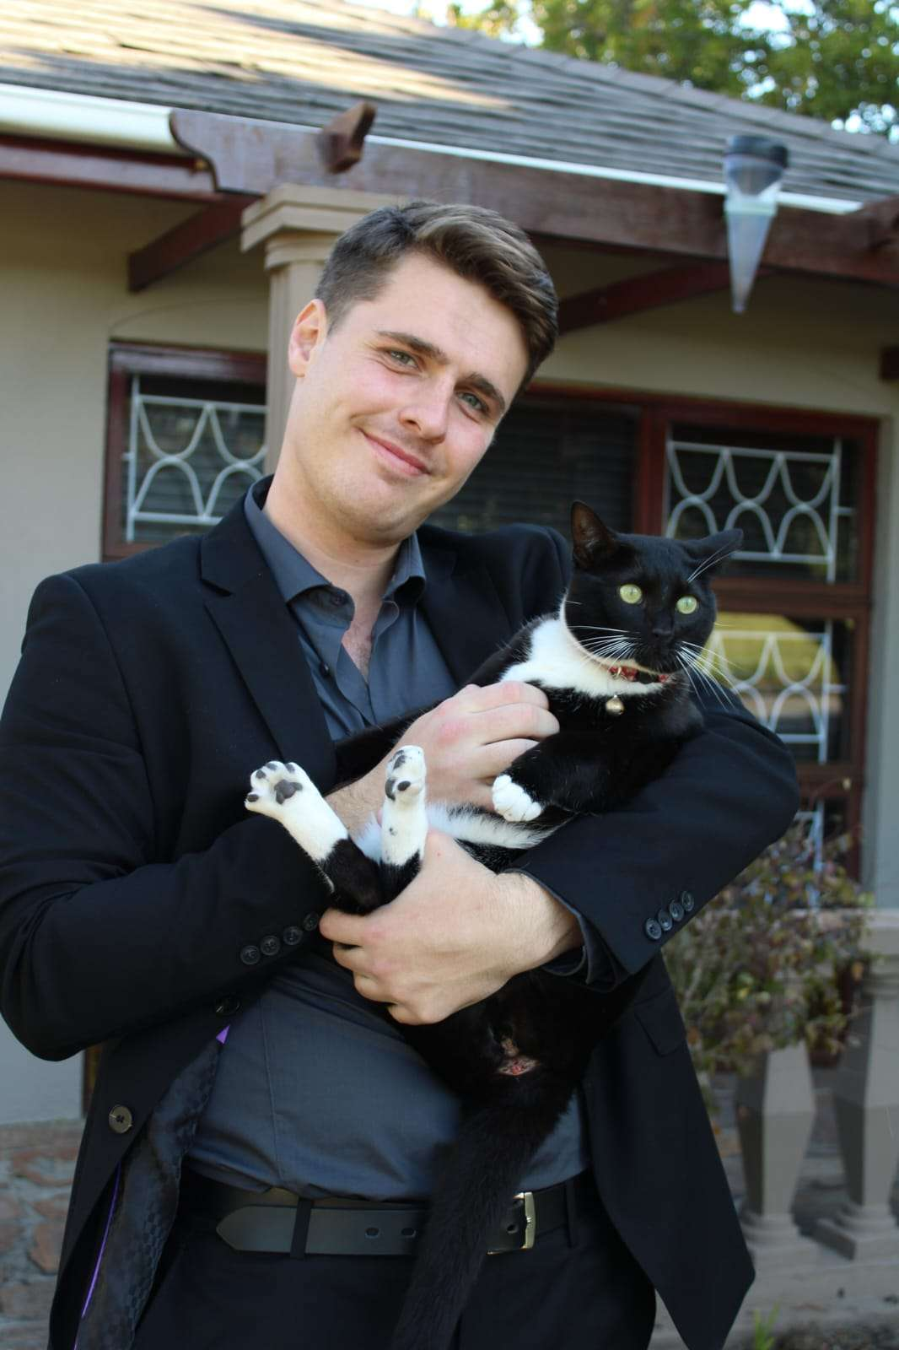

**Software Developer**

***Summary***



**Eduvos, Cape Town, SA**   
2024-2027 (Graduation Year)

Bachelors of Information Technology Science (Software Development)

***Education***

* Video Games
* Fitness
* Game development

**Game developer**  
Self-Employed  
February 2021 – Present

* 3 years of Game development on Unity using C#.
* Created and released my first mobile game (Pongify) on Play store (2022).
* Created and released my second mobile game (Snek) on Play store (2023).
* Currently working on my first PC Game that I Plan on releasing on Steam.

***Experience***

My name is Marcus, I have been doing game development for around 3 years now, I have different levels of experience in coding languages as well as using Microsoft Applications. I am strong willed and always looking to improve, whether it is physically or mentally.

* C#
* Python
* Pascal
* Html
* CSS

***Languages (Coding)***

* Afrikaans - C2
* English – C2

***Languages (Speaking)***

* Coding Skills
* Programming Languages
* Adaptability
* Problem-Solving
* Reliability
* Microsoft Office
* 3D modelling & Pixel Art

***Skills***

***Hobbies***

**MARCUS SCHOEMAN**

**060 436 0021  
Marcusjschoeman@gmail.com  
Cape Town - SA**